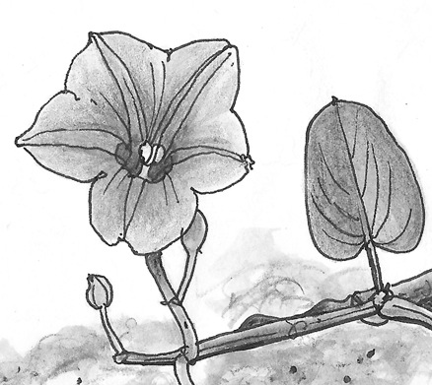
Grand Isle Garden Club Membership Form
Ipomoea pes-caprae
(Railroad Vine)

The Grand Isle Garden Club is a friendly new initiative to
support the Town of Grand Isle in gardening related activities
such as encouraging civic beauty, stimulating roadside beautification
and conserving and protecting our natural resources.

Founded July 02, 2015 • Member: Louisiana Garden Club Federation

Join us! Thank you for your support! 2019–2020 (June 1st – May 31st) Dues $10⁰⁰

Drop off this form & dues to Louise LaFont at the Tourism Office (2757 LA-1, Grand Isle, LA 70358)
or Bonnie Pizani at Town Hall (170 Ludwig Ln, Grand Isle, LA 70358).
Your photo may be taken at GIGC meetings or events and used in our Club scrapbooks in print or online. Please check this box to authorize use of photos. Thank you! ☐ ________
initials

Name_________________________________________________________
Mailing Address________________________________________________
________________________________________________

Telephone_____________________________________________________

Email_________________________________________________________
We will be communicating Club news via email, on facebook and through our website.
We will NOT share email address for commercial purposes.

GI property address_____________________________________________

Signature:____________________________________________________
Date

